Tamkang Times No.828
2011 Tamsui Campus Commencement

On the 11th June, over 7,000 TKU students officially graduated in a large-scale graduation ceremony held at the TKU Tamsui Campus. The main ceremony was held in the Shao-Mo Memorial Gymnasium and was broadcast simultaneously on large TV screens across the campus and online.

The ceremony took the theme “the TKU Diamond Jubilee, a Milestone for You and Me”. It commenced to the thundering beat of drums, and proceeded with a colourful and lively dance display and magic show performed by members from various TKU clubs and societies. The unique magic show consisted of a series of card tricks in which the magician cut to cards in the deck that conveyed touching messages and well wishes for the graduating students.

His act was followed by speeches from the President of TKU, Dr. Flora Chai-I Chang, and the El. Salvadorian Ambassador to Taiwan, Martha Chang de Tsien, among other VIP guests. Of note was a speech made by a graduating TKU international student from El Salvador, Flora Menjivar. It was special, in part, because of the fact that it was delivered in fluent Chinese – a testimony to Ms. Menjivar’s diligent efforts over the last four years.

Meanwhile, during her opening address, President Chang commended the graduating class on achieving this personal milestone. She emphasized TKU graduates’ popularity among Taiwanese enterprises, pointing to the Cheers Magazine survey that has placed TKU graduates first in this field among private university graduates for 14 successive years.

She also reiterated a famous quote from Winston Churchill, which she had cited in a speech at San Francisco University (SFSU), after being recognized as the 2011 SFSU Alumna of the Year:

“Success is not final, failure is not fatal: it is the courage to continue that counts”.
2011/06/20

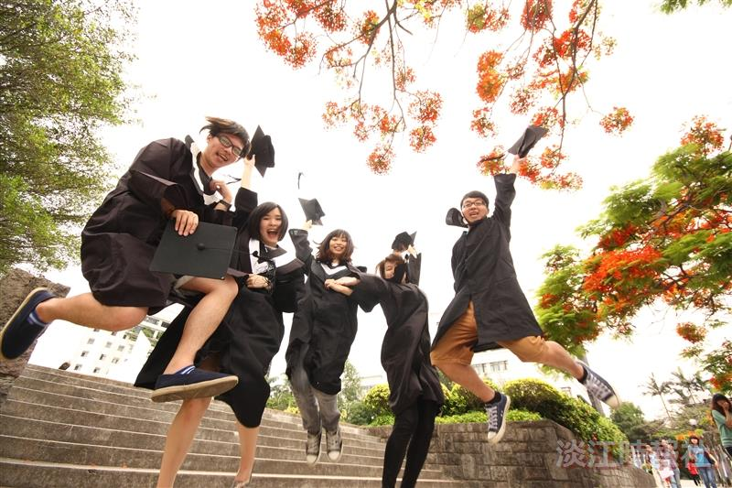
Time: 9am, June 11?
Starting point: Student Activity Center, Tamsui campus

