Tamkang Times No.827
Garbed in Retro to Show Gratitude

Last month, the Chinese palace-style classrooms that border the Chueh-Sheng Chinese Gardens were home to the 13th Department of Information and Communication End-of-Semester Dance Party. The party was organized entirely by department freshmen. It was their way of saying ‘thanks’ to the second, third, and fourth year students who had looked after them when they had first arrived.

The theme of the party was retro. As such, students were required to wear retro attire and accessories, such as 90s style polka dot outfits and suspenders. During the party, attendees were treated to a range of entertainment, including six short musicals that engaged and amused the audience.
2011/06/10

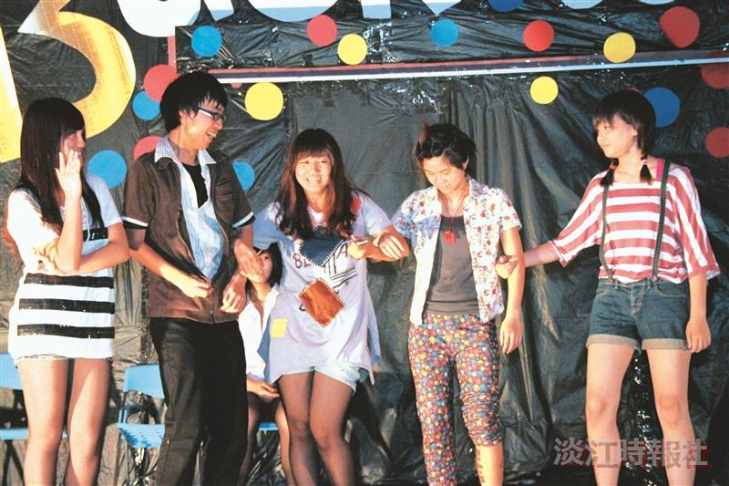
Department of Information and Communication freshmen in retro attire at the End-of-Semester Dance Party.

