Tamkang Times No.825
The 26th Annual Kendo Invitational

On May 15th, the TKU Kendo Society held the 26th National Intercollegiate Kendo Invitational. Close to 300 Competitors from 25 universities around Taiwan crowded into the TKU Shao-Mo Memorial Gymnasium in the hope of snatching competition success.

As the competition began, the TKU women’s team breezed through the qualifying rounds and sauntered into the championship final, where they met National Chiao Tong University. The final was a tight battle and, in the end, was clinched by a single point. That point belonged to Chiao Tong University. The captain of the TKU team, Wang Pei-Ru, noted that “competitions require a bit of luck and hard work in the regular training schedule. Although in the end we lost today, all we can do is stay positive and keep training.”

As for the men’s team, in the qualifying rounds, team Captain Li Fei-Peng recorded five successive victories to earn a berth in the preliminary finals. This year, however, his winning streak ended in the preliminaries. He lamented: “Although we didn’t do as well as last year, we all gave it our best. Hopefully next year we’ll go on to claim the championship”.
2011/06/01

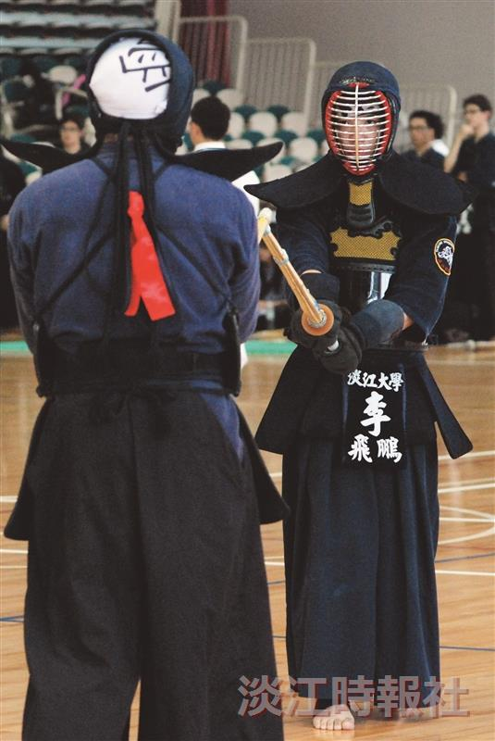
Kendo practitioners square off in preparation to spar at the 26th Annual Kendo Invitational.

