Tamkang Times No.825
The TKU Robot Research Team Triumphs Again

On May 14, the TKU Department of Electrical Engineering’s ‘Robot Research Team’ competed in the 'Taiwan Intelligent Robot Competition' held by Southern Taiwan University. Out of 170 teams from across Taiwan and overseas (Canada, Australia), the TKU team took first place in the category ‘Intelligent Humanoid Physical Ability Contest’.

This year, the Robot Research Team was again led by Prof. Wong Ching-chang of Tamkang’s Department of Electrical Engineering, and consisted of 10 Electrical Engineering students, including the team captain, 3rd year PhD candidate Hu Yue-Yang.

Their outstanding achievement can be attributed to countless hours of training and preparation outside of competition time. Such tireless efforts have seen the TKU team construct and develop various robot models, including a FIRA medium-sized soccer robot, a RoboCUP medium-sized soccer robot, a humanoid robot, a housework robot (to help with chores around the house), a security robot, and a basketball-playing robot.

Since 2001, the TKU robot research team has claimed a total of 116 awards and competition placings in both local and international contests.
2011/06/01

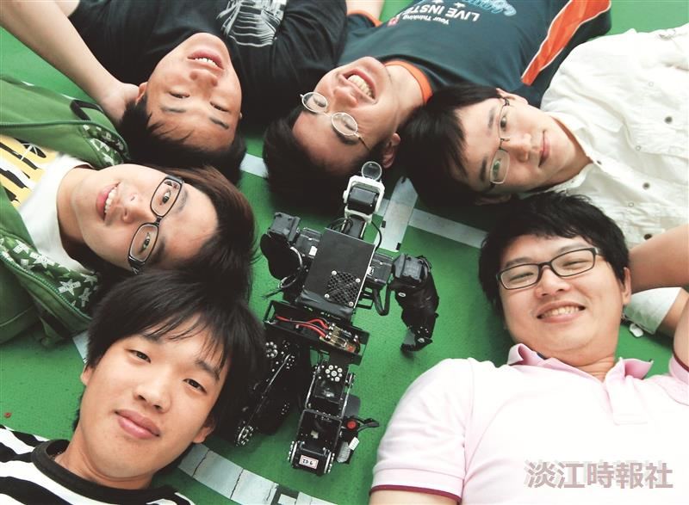
The winning robot team with their championship robot.

