Tamkang Times No.822
A Wild Bird Exhibition at Lanyang

From April 26 – June 7, TKU’s Lanyang Campus will be home to a special photography exhibition. The exhibition will showcase 60 photographic works that capture the beauty of Taiwan’s wild birds in their natural habitat. The pieces were generously donated to TKU by well-known photographers and husband and wife, Mr. Kuo Keng-kuang and Mrs. Huang Mei-e. In honor of the couples’ generosity, on April 26 the Lanyang Campus Office of the Director held an official ceremony to inaugurate the donated photographic works. Apart from the husband and wife donors themselves, a host of high-profile local dignitaries attended the ceremony, including the Deputy Director of the Yilan County Cultural Affairs Bureau, Sung Lung-Chuan.

The Director of Lanyang Campus, Dr. Lin Jyh-horng, said he hopes that through the exhibition, TKU can spread information on the ecology of bird species to the broader community, that it can nurture in visitors an appreciation of art and nature, increase the public’s knowledge of bird species, and promote the need to protect Taiwan’s natural ecology.
2011/05/17

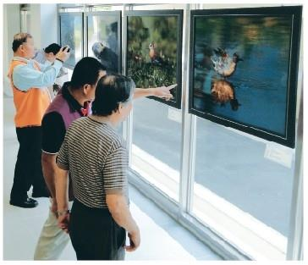
Visitors at the Lanyang Campus Wild Bird Exhibition eagerly discuss the photographic works on display.

