Tamkang Times No.808
A Trip to the Guandu Nature Park

The course “Ecological Community Construction”, taught by lecturer Lu Yao-qin and offered by the Center for General Education and Core Curriculum, is a popular one. Recently, as part of the course, students were taken on a field trip to the nearby Guandu Nature Park, where they took part in environmental protection volunteer service. Lu Yao-qin pointed out that the Guandu Nature Park is a vital international wetland. He said the field trip was organized to teach students that protecting the environment requires everyone’s collective efforts. And given that society is moving toward a volunteer-style social model, the field strip was an invaluable experience for TKU students. For most students, this was their first time wearing waterproof suits and rain boots. And so as they took their first steps into the wetland pond, many students slipped on the mossy rocks, but were caught and supported by their classmates. The group demonstrated true teamwork.

A fourth year Department of Information Management student who took part in the trip said that he chose the course because it was highly recommended by TKU students on the internet. After the field trip experience, he clearly understood why. He now also understands that environmental conservation requires concrete actions, not just empty words and fancy slogans. He expressed his hope that everyone may one day truly understand the importance of protecting the environment.
2010/12/29

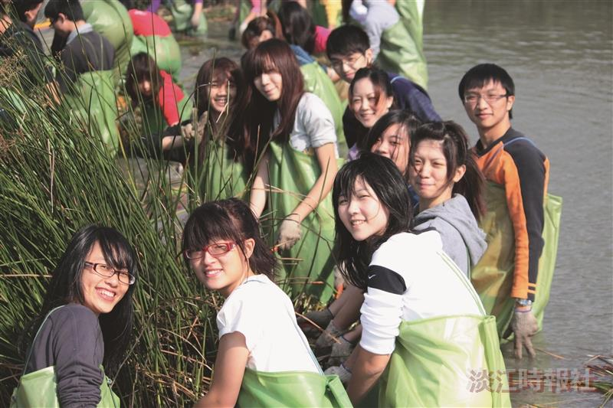
Students don waterproof suits and help extract reeds as part of a field trip to the Guandu Nature Park. The field trip is a component of the TKU course Ecological Community Construction, which teaches students about the importance of environmental protection.

