Tamkang Times No.808
A Dual-Purpose Opening Ceremony

On Dec. 16, the TKU College of Engineering held an opening ceremony to celebrate the relocation and extension of the College of Engineering’s CAE Laboratory. As an adjunct to the ceremony, TKU President Dr. Flora Chia-I Chang and the General Manager of MITAC Corp. Mr. Jiang Tai-fang concluded an extensive cooperative agreement.

Relocation of the CAE Laboratory began during the summer holidays. The Dean of the College of Engineering, Ho Chi-dong, noted that the relocation also involved an expansion of the laboratory’s original size. The laboratory originally comprised 1 large classroom, 2 medium-sized classrooms and 1 small classroom, and could accommodate 140 students. It now consists of 4 large classrooms, 1 medium-sized and 1 small classroom, and can seat 360 students. In terms of facilities, it’s now equipped with 180 state-of-the-art computers, to provide engineering students with the ideal learning environment.

Information-oriented education has always been a primary focus of the TKU academic curriculum. This focus has enabled TKU students to achieve remarkable results both in the field of software design, as well as in several digital design competitions. And now, with the most cutting-edge tools at their fingertips, TKU engineering students will have an even greater competitive advantage when entering the workforce.

The agreement with MITAC, which was signed during the opening ceremony, stands to further bolster TKU’s information-based capability, and to tighten the cooperative relationship between TKU and the technology sector. It will involve intern opportunities and scholarships for a handful of diligent students. Jiang Tai-feng noted that the affinity between TKU and MITAC runs deep, with many outstanding TKU alumni among the ranks of MITAC employees. He said that he hopes to create a close cooperative partnership with TKU, and to generate a mutually beneficial synergy between academics and business.
2011/01/03

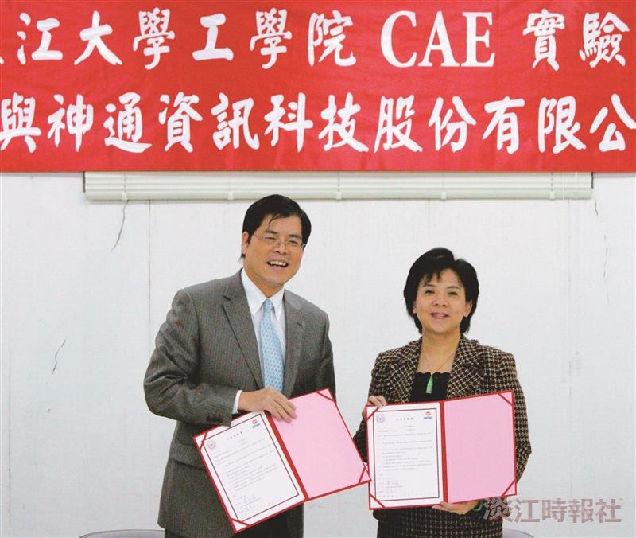
The President of TKU, Dr. Flora Chia-I Chang, and the General Manager of MITAC IT Corporation, Jiang Tai-fang, conclude an extensive partnership agreement.

