Tamkang Times No.807
TKU and Aletheia Make Melodious Music in Tamsui

On the 8th of Dec., TKU’s Center for General Education and Core Curriculum held a joint concert with nearby Aletheia University at the Tamsui Campus’ Carrie Chang Concert Hall. Several professors from both Tamkang University and Aletheia University produced remarkable joint performances using the piano, cello and violin, and the oboe. There was even a soprano performance which provided a stunning conclusion to a night of melodious classical music.
2010/12/22

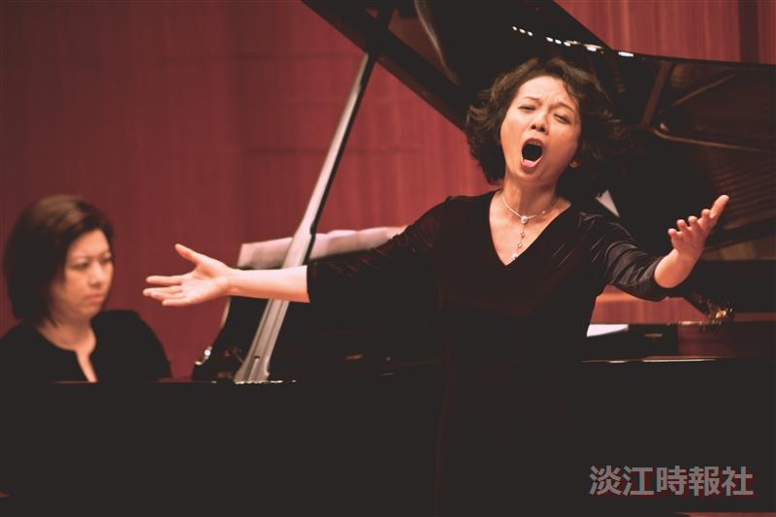
Aletheia University faculty member Chen Xin-yi performing during the jointly held Tamkang – Aletheia Concert

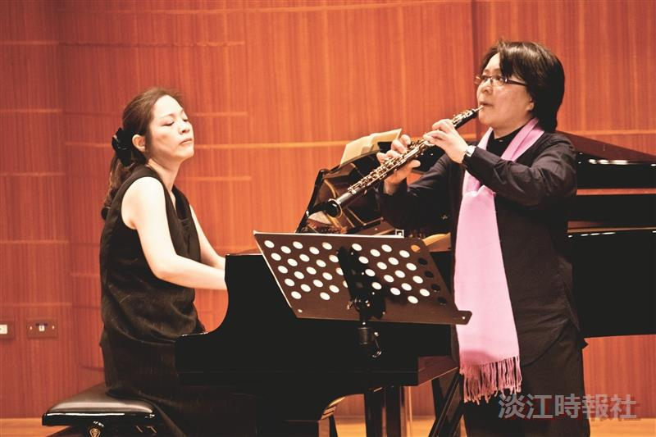
The Center for General Education and Core Curriculum’s Chris Gan (right) and Li Pei-yee (left)

