Tamkang Times No.803
Foreign Language Alumni Enjoy a Cultural Extravaganza

On the 6th of November, the College of Foreign Languages and Literature staged a cultural extravaganza. It was a show featuring dances by each of the college’s departments, including the department of Spanish, French, German, Japanese, and Russian. Over 400 department alumni returned to take part in the cultural activities.

The entertainment segment of the program comprised a flamenco performance by the Spanish Department, a traditional German folk dance, and several dance numbers traditionally performed during the Japanese Awa Dance Festival, among others.

After the performances, the crowd shuffled down to the basement level of the College of Foreign Languages and Literature building, where they were treated to a pastiche of gourmet delicacies, including macaroons and sushi. Assoc. Prof. Jose Miguel Blanco Pena even brought cooking materials and, on the spot, began cooking Spanish seafood risotto and clams.

The alumni savoured the gourmet treats while reminiscing about their student days. One member of alumni in his eighties was in the first class of students to graduate from the TKU French Department. He said “I still feel a close connection with the TKU French department, so I come back to attend alumni activities every year. I’m still studying French. I brought my French tutor with me today to share in this momentous occasion”.
2010/12/17

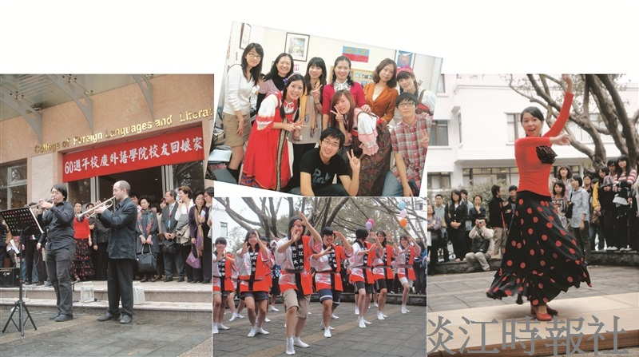
Five separate departments from the College of Foreign Languages and Literature showcase cultural dance performances.

