Tamkang Times No.802
Hiking Mt. Kuanyin

On the 31st of October, around 200 people hiked up Mt. Kuanyin in picturesque Tamsui. They scaled the mountain as part of “the Great Kuanyin Hike”, a bygone Tamkang tradition revived, in part, to mark Tamkang University’s upcoming 60th anniversary. The hike was a jointly organized event, and participants came from a number of local welfare and Cub Scout groups with connections to Tamkang University. A notable participant in the hike was the President of Tamkang University, Dr. Flora Chia-I Chang, who doubled as a team leader.

“Those who haven’t hiked Mt. Kuanyin can’t really call themselves Tamkangians”, exclaimed Tamkang University Prof. of History, Luo Yun-zhi. His comment was a reference to Tamkang’s close affinity with its mountainous natural surrounds. Tamkang students often win prizes for artwork depicting Tamsui’s mountains and rivers; and there is even talk of the Kuanyin Mountain hike one day becoming a compulsory activity for all Tamkang students.

The importance of the hike owes partly to its place in Tamkang history as a venerable tradition. The tradition vanished for an entire decade, but under the joint efforts of various local groups, it has now returned. The hike is a chance for teachers, students, and participating groups to take a break from their busy schedule, and get out amongst nature. After the hike, a raffle was held and one lucky participant went away with a new laptop. All participants, however, came away with a memorable experience and a renewed appreciation for the beauty and tranquility of Tamsui.
2010/12/20

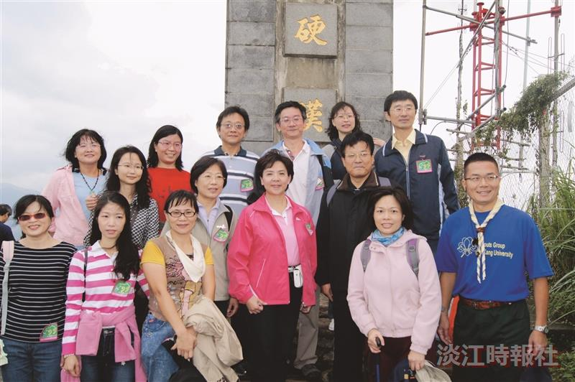
While hiking Mt. Kuanyin, TKU President Dr. Flora Chia-I Chang leads her group to the summit, where they take a group photo.

