Tamkang Times No.801
Visiting Students Captivated by TKU Tamsui Campus

On Oct 28, high school students from Annecy City in France visited the TKU Tamsui Campus. They were received by students in the TKU Department of French, who not only provided a description of local Tamkang and Tamsui culture, but even prepared a local Tamsui delicacy – fish crisps. After her first mouthful, high school student, Capucine, exclaimed in Chinese “Hao Chi” (“It’s delicious!”).

TKU French students also organized a tour of the campus for the visitors. Their introduction of the campus was delivered mainly in French; but at times, tour guides’ French vocabulary failed them, and they reverted to using English, which drew laughter and smiles from the lively group. As they reached the Chinese palace-style classrooms and Chueh Sheng Gardens, visiting student Mathilde said that she had never seen such architecture before, adding “It’s so beautiful”.

TKU first year French student, Lin Yin-xuan, said that thanks to this event, she now has a deeper understanding of French culture, and “really wants to go to France to experience the culture first hand”. Meanwhile, second year French student, Wei Mei-qi, conceded that “Although they kept saying our French is really good, after this experience, I’ve realized that there’s plenty of room for improvement”.
2010/12/17

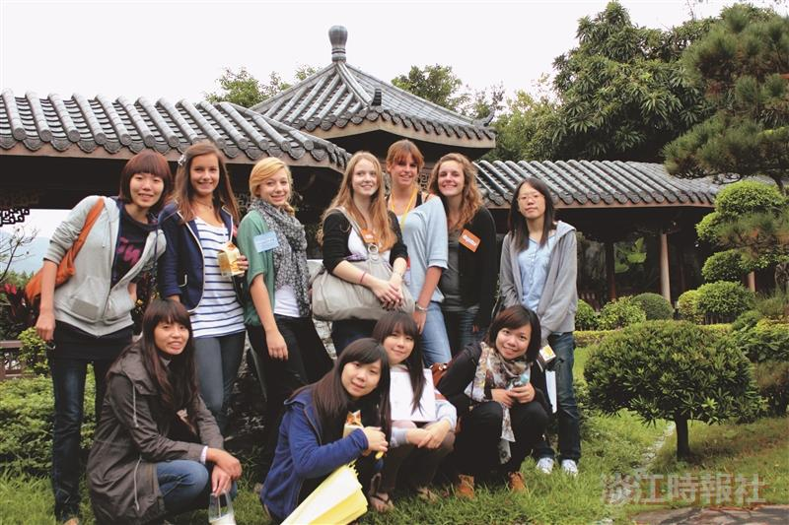
French high school students visit Tamkang’s Tamsui Campus. Astonished by the beauty of the Chueh Sheng Chinese Gardens, they ask for a group photo in the lush garden surrounds.

