Tamkang Times No.800
A Tamkang Concert Spectacular

Tickets for the TKU Diamond Jubilee concert are now available. From today (Mon. Oct. 25) until Fri. Oct. 29, between 10am and 5pm, students and faculty can collect tickets from the ticket stand at the third level entrance to the College of Business and Management building by simply displaying student ID or faculty cards. Tickets for TKU alumni will be available on the 28th and 29th of October. Yet with just 1500 tickets reserved for alumni, former TKU students will have to act fast.

Concert tickets have been thoughtfully designed in the shape of guitars. On the day of the concert, from 4:30pm, students can display the guitar-shaped ticket to receive a commemorative Diamond Jubilee collector’s card. Entry to the concert will begin at 5:30pm on November 5. The concert will begin at 6:30pm, and will be held at the Student Activity Center, at TKU’s Tamsui Campus.

The concert will feature various Tamkang alumni artists and entertainers, including TV personality, Bu Xue-liang – who will host the event – as well as an array of talented singers: Xiao Huang-qi, Shi Hsiao-rong, Guo-jing (Claire), Ma Nien-Hsien, and Crowd Lu. The artists will not only perform their own hit songs, but will also come together to sing the Tamkang campus song.
2010/12/17


Students who complete the TKU questionnaire and attend the concert have a chance to win the limited edition TKU monopoly board game.

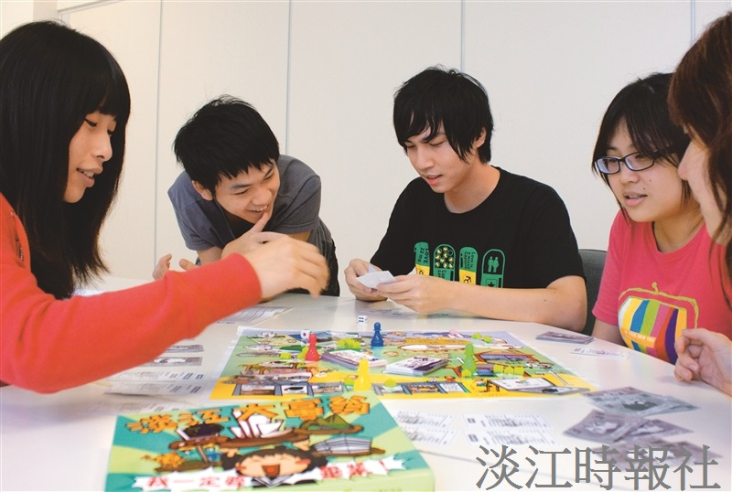
Students who complete the TKU questionnaire and attend the concert have a chance to win the limited edition TKU monopoly board game.

