Tamkang Times No.806
The EU Short Film Competition

The presentation ceremony of the National 2010 European Union Short Film Competition was held recently, on the evening of Nov. 29. The winning film was a joint production by TKU Graduate Institute of European Studies student, Lin Pei-heng, and National Taiwan University of Arts student, Wang Wen-yi.The two students drew on their deep understanding of European culture and expert film production skills to design a vivid short film based on the theme of a postcard.

Lin Pei-heng said that in producing the film, she hoped to enhance Taiwanese people’s understanding of Europe. The film features her language exchange experience with a French student, which was the core motivation for her later trip to Europe to pursue further studies.

Students of the Department of Information and Communication, Zhang Jia-yu and Wu Shu-min, were also among the competition winners, with a third placing for their short film, which took the theme “the European Union and Taiwan”.

The Director of the TKU Center for European Union Studies, Dr. Kuo Chiu-chin, noted that Liu Pei-heng’s first placing reflected a team effort, whereby various classmates from the Graduate Institute of European Studies lent their support, providing voiceovers, guest appearances etc., in what was a rare and very well-coordinated group effort.
2010/12/15

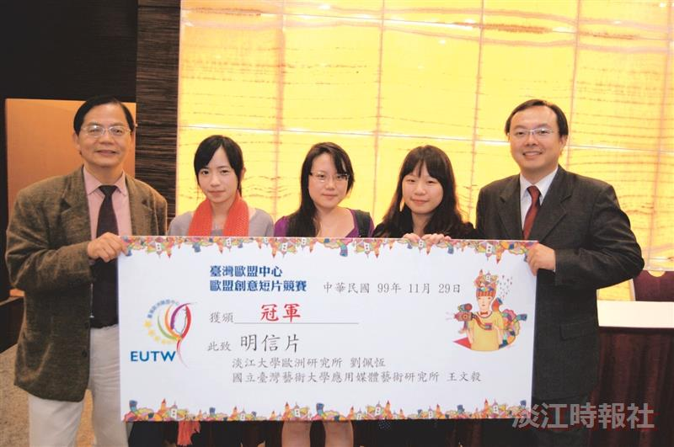
Director of TKU Center for European Union Studies Dr. Kuo Chiu-chin (left); competition winner Liu Pei-heng (2nd from right); and Executive Director of the European Center in Taiwan Marc Chia-Ching Cheng (right).

