Tamkang Times No.793
ALUMNUS OF DEPT. OF MASS COMMUNICATION, LEI KUAN-HSIA CREATED “FRUIT” FOR TKU’S 60TH ANNIVERSARY

To celebrate TKU’s 60th anniversary, our school has invited alumnus of Dept. Of Mass Communication, Lei Kuan-hsia, who had won prizes in Golden Melody Competition, to create special theme song. The result, “Fruit,” was completed, with Lei’s performance being filmed as MV by Wang Liang-chun, Chen Fang-wei, and Chuan Chien-hui, who are all alumni of Dept. Of Mass Communication. The MV was posted in University Exposition, which has won wide response from audiences. Those who are interested can visit the website at http://www.youtube.com/watch?v=15HoF-ZUAfU. ( ~Chen Chi-szu )
2010/09/27

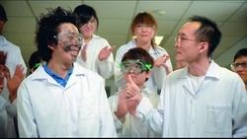
“Fruit” a theme song for the TKU anniversary celebration, created by alumnus Lei Kuan-hsia. The MV has won wide response. The film clip features the protagonist winning his teacher’s praise for his tireless experiments.

