Tamkang Times No.787
REPORTS ON “FRESHMAN LEARNING AND STUDYING STRATEGIES SURVEY”

The 2009 academic year “Freshman Learning and Study Strategies Survey” organized by Student Learning Support Section, Center for Learning and Teaching, was released recently, with 97.92% of total students and 5392 freshmen surveyed. Hsu Chia-ling, Section Chief, indicates that the survey aims at providing data for tutors to better understand their students’ learning situations, and then helping students to anchor with better studying strategies and improving bad habits.

The survey consists of 11 evaluation items, including attitude, motivation, time management, depression, concentration, message management, grasping the main points of lesson, assistance technique, self-test, examination strategy, problem-solving strategy. In each item, the ration higher than PR75 indicates a good learning trait, and that lower than PR50 suggests a poor trait. According to statistics, more than 50% of the surveyed freshmen have problems in depression, concentration, assistance technique, and examination strategy. And more than 50% of the freshmen in every college have problems both in depression and in examination strategy.

Hu Yen-wei, Section Chief of Counseling Section, responds to the problem of depression that freshmen walk in the transition between high school and university, and suffer challenges in independent study, new social activities, communication, loneliness, competition, and uncertainty about the future; hence, they would feel more puzzled and anxious then before. In addition to heightening their motivation, changing learning strategy, and using assistance techniques, it is more urgent to locate their individual core problem, such as relocating their role of studying. Counseling Section has provides placement assistance counselors to help students find out their own goals. All students are welcome to use such a resource.

In response to the problem in examination strategy, Hsu Chia-ling, Section Chief, Student Learning Support Section, suggests students to utilize the learning and examination tips in “Make you All Pass” of the “Freshman Learning” Course. If they still can not handle their learning method and free time, they can find help from the Section to reregulate their studying plan and schedule. In addition, they can join the Basic Remedial Course offered by the Section or each department in clarifying the basic idea of lesson, and learning examination tips.

The freshmen in College of Science, College of Engineering, and College of Management, have more urgent problems in 5 items, with PR ratios lower than 50 and more than 50% of student numbers; while College of Education gets 4 urgent items; College of Liberal Arts, College of Foreign Literatures and Languages, College of Entrepreneurial Development respectively gets 3; College of Business and College of Global Research and Development respectively 2. Dr. Wang Bo-cheng, Dean of College of Science, indicates that freshmen in his college, compared with those in other colleges, undertake more difficult subjects, hence, suffer more stresses and have more problem in examination strategy. In response to the problem, his college will ask tutors to focus on counseling students’ studying and stress management and the college plans to add more small-size study assistance classes by teaching assistants. ( ~Chen Chi-szu )
2010/09/27

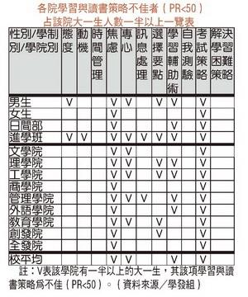
The “V” marks indicate that there are more than 50% of total freshmen in the college with poor learning and studying strategies (PR&lt;50) in the surveyed item.

