Tamkang Times No.779
INTERNATIONAL ARTS EXHIBTION IN TKU

In accordance with the “Spring Festival” alumni reunion activities, Carrie Chang Fine Arts Center hosts the “Taipei Modern Art Exhibition,” from March 13 to May 2. The opening ceremony will take place at 11 AM, March 16. Everyone is welcome to appreciate the works of internationally noted artists.

The artists include the 21 artists participated in the “24th Asia International Arts Exhibition” held in 2009, Malaysia. Both Chinese paintings and western paintings in diverse styles are shown in the exhibition. Koo, Chung-kuang, a Artist-in-residence of TKU, presents an oil painting, “Twelve Persimmons,” in neo-realist style. Lee Chong-chong exhibits an abstract ink painting, “The Voice of the Earth.” Koo indicates that these works of diverse styles witness the development of Taiwan modern painting in the hands of second generation artists. ( ~Chen Chi-szu )
2010/09/27

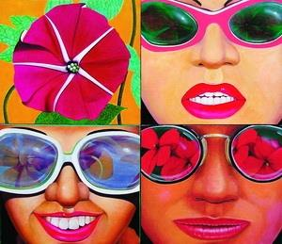
“They Love Big Flowers,” an oil painting by artist Liu Hsien-chung, was exhibited in “Taipei Modern Art Exhibition,” Carrie Chang Fine Arts Center. The bright flowers reflecting on the sunglasses of young girls reveal the humor of post-POP art.

