Tamkang Times No.771
COLERFUL LIFE AT TKU

The list of winners of the photography contest “Capture the Moments of TKU Life” by the TKU Student Association is out! Mass Communication senior Shu-wei Huang won the championship, and her winning work “It’s Colorfully Flowering” has captured the moment while graduates are throwing their colorful flowers in the air to show their wild happiness for their successful graduation.

The Executive Secretary of the TKU Life Festival, Japanese sophomore Yu-shan Huang thanked the participants whose votes would leave a colorful mark in TKU life. An album of the winning photos will be published, and the Album will be distributed at the TKU Life Festival. There will be 6 winners for the top 3 prizes and 14 for the Excellent Wok Prizes. The list of all winners will be published at the Website of the TKU Student Association: http://www.wretch.cc/blog/tkusa15th. ( ~Dean X. Wang )
2010/09/27

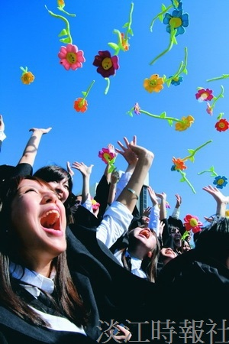
TKU Student Association held the photography contest “Capture the Moments of TKU Life.” Many students participated, and here are some of the participating works.

