Tamkang Times No.745
GRADUATION EXHIBITION HIGHLY PRAISED BY ESLITE

The 9th Graduation Achievement Exhibition by the Department of Educational Technology went on in the Black Swan Exhibition Hall on March 17. President Flora C.I. Chang, Administrative Affairs Vice President Po-yuan Kao, College of Education Dean Hsun-fang Kao and Eslite Personnel Department Director Fa-chi Lin were invited to the opening ceremony. President Chang said that this time, students’ creativity conformed to the designing theory of the Black Swan Exhibition Hall. Obviously the students knew not only educational technology but also skills of sale.

At the opening ceremony, the Department of Educational Technology Chair Ya-ping Huang thanked enterprise owners who had given students encouragement and recognition. Educational Technology senior Chi-yi Chuang who had written The Assisting Teaching Material for the Eslite New Comers said that he had put in a great deal of effort into it while communicating, coordinating and exchanging ideas with the business owner. Students’ earnest manner convinced Fa-chi Lin that Eslite would cooperate with students of the Department of Educational Technology next time. He highly praised, “The achievement of the students is outstanding!” ( ~Dean X. Wang)
2010/09/27

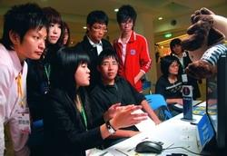
Students are earnestly explaining their graduation achievements.

