Tamkang Times No.743
FOUNDER CHANG WROTE TO CELEBRATE THE 40TH ANNIVERSERY OF THE YILAN COUNTY FELLOWS ASSOCIATION

To celebrate the 40th anniversary of the Taipei-Yilan County Fellows Association, TKU Founder Clement C.P. Chang wrote “Heart for Lanyang and Feeling for Hsueshan” for the special celebration edition of Lanyang Magazine Vol. 90, nostalgically talking about his happy recollection of dozens of years of coming and returning to and from Lanyang.

Founder Chang served as the Director of the Taipei-Yilan County Fellows Association in 1965, and in the following year he set up Lanyang Magazine and also became its publisher. The most frequently discussed topic was how to improve the transportation system and establish a university. He spared no effort to promote the construction of Taipei-Yilan Highway. First, in 1985, he initiated “Taipei-Yilan Rapid Transportation System Promotion Association,” hoping to improve Yilan’s transportation that could led it to the outside world. In 1989, Founder Chang became the Minister of Transportation and Communications, and afterwards, for Yilan’s overall long-term development, he tried vigorously to convince the Executive Yuan to upgrade Taipei-Yilan Express Way to Taipei-Yilan Highway. The Executive Yuan finally approved the case in 1990. The construction started in 1993 and the Highway opened for use in 2006. As the transportation was well improved, Yilan County changed into an industrial and commercial county from an agricultural one.

Founder Chang has devoted his whole life to education. In 1950, he assisted his father, Mr. Ching-sheng Chang, to have set up the Tamkang College which has been developing into the fully fledged comprehensive Tamkang University with nearly 30,000 students, the biggest private university in Taiwan. After half a century, with the hope to contribute whatever he could to his hometown, Founder Chang established the Lanyang Campus at the scenic Mt. Linmei in Chiao-hsi, I-Lan. He expressed, “It is a very meaningful thing to contribute my precious experiences in education accumulated in most of my life to the development of education in my hometown.”

Both the construction planning of the Lanyang Campus and the Taipei-Yilan Highway started in 1989 and both completed in 2006, so they are like beautiful twins born after a long-term nurturing. This makes Founder Chang feel very gratified. ( ~Dean X. Wang)
2010/09/27

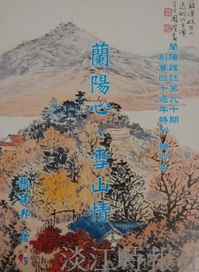
Founder Chang wrote to celebrate the 40th anniversery of the Yilan county fellows association.

