Tamkang Times No.740
CHERRY BLOSSOMS WELCOME THE NEW SEMESTER

Along with the coming of spring, cherry blossoms, the school flower of TKU, have already bloomed everywhere in the campus, welcoming a new semester.

The cherry trees beside the Maritime Museum have been in flower already. The thriving pink blossoms turn into a sea of flowers, which attract everyone’s attention, making them stop walking and appreciate the beautiful scenery. Some of the students even took a picture with their camera to grasp the fantastic moment.

Beside Student Activity Center, and at the lawn in front of the post office as well as Ying-yuan, the cherry trees are ready to bloom. Under the golden sunshine, the pink cherry blossoms swing with the breeze, decorating TKU campus in the spring. ( ~Shu-chun Yen )
2010/09/27

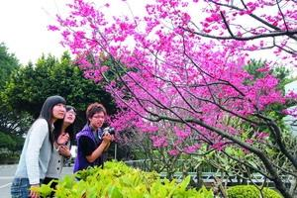
The cherry trees are in full bloom at Tamsui Campus. Many people stopped and appreciated the beautiful scenery. Some even took a picture to grasp the fantastic moment.

