Tamkang Times No.733
LEARNING A HISTORY LESSON BY MAKING SANDWICH

Do you know that you can learn a history lesson by making yourself a sandwich? Don’t be surprise as it is how Dr. Tai Yueh-fang, a professor in the Department of History teaches her students in a course entitled, “Practical History.” During a class on November 20, Tai asked her students to make use of the historical stories and theories they learned from the course to make themselves a sandwich. In this original history class, students had all done their best to come up with creative menu and dishes by making use of self-prepared materials. Wang Yueh, Chair of the Department of History and former Chair Huang Farn-guang were both invited to the class to have a taste of these innovative sandwiches made by the students. “This is a very different and unique way of teaching of helping students to make use of what they learned in the history class into daily life,” said Tai. “In this way, history is not merely a course, but a knowledge that can be practically used by students in their future career.” ( ~Yeh Yun-kai )
2010/09/27

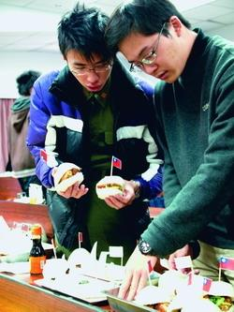
Students are seen making sandwiches to learn history.

