Tamkang Times No.721
452 TKU STUDENTS JOIN ABROAD STUDYING PROGRAMS:

The 2008 academic year flag-giving ceremony for the Junior Abroad, Graduate Abroad Studying, And Exchange Students Programs was held on June 25. With totally 452 abroad studying students, TKU outnumbers all other universities of the country. Dr.Tai Wan-ching, Vice-President for International Affairs, remarked happily in the ceremony that “According to the statistics of Global Views Monthly, last year TKU’s abroad studying students outnumber all other national schools. This year we will be the champion again.”

The flag-giving ceremony was hosted by President C. I. Chang. The flags were presented by Founder Clement Chang. The participating students and their parents are invited to the ceremony. Founder Chang encourages the students that the aim of abroad studying is not only to know the broad world, but also to more fully understand oneself and progress.” He indicates that the “quantity” of such a program has reached to a favorable standard, and our next efforts will be focused on the “quality.” He urged the chairperson and academic advisers of each department pay close attention to caring for the TKU students in abroad via internet and other channels, and he also reminded the students to keep contacts with their departments.

Mr. Nicholas Papp of AIT, and Mr. Jurgen Gerbig of Deutsches Kulturzentrum Taipei and other representatives from diverse countries were invited to address to the audience. Mr. Thierry Coste, language teacher of International Cooperation Section, Institu Francais de Taipei, indicates that Tamkang University offers more students to France than other Taiwan schools, and those students will become important cultural ambassadors to introduce Taiwanese culture to the French and other foreign people so that the communication and student exchange of both countries would be increase year by year.

Among the 452 students, 49 are exchange students to TKU sister universities, 189 are from Langyang campus, 154 from College of Foreign Languages and Literatures, 49 from the Special English Class of Dept. of International Trade. They are going to 63 universities, in 15 countries and four continents (America, Europe, Asia, Australia). According to statistic, the top three popular choices are Winona State University (40 students), Indiana University of Pennsylvania (37), and California State University, Sacramento (33).

Two ex-participants, Tsai Yi-shan, senior of Dept. of Japnese, and Liu Hsing-chang, senor of Dept. of Software Engineering were invited to speak to the new participants about their abroad studying experience. Liu stated that he returned from California State University, Sacramento, and the all-English speaking environment of Lanyang campus made him adjust to the foreign environment very quickly.

Huang Yen-chung, junior of English department, and Huang Chi-hsian, second year master graduate program of Dept. of International Trade, who will go to study in University of Queensland, Australia, express their excitement to have such a chance to broaden their world view and for personal progress. Sun Yung-chung, father of one participant, Sun Shao-chang, junior of Japanese department, was invited as a parent representative to encourage the abroad studying students. Tseng Hsin-hua, junior of Department of Global Politics and Economics, Langyang campus, who will go to Kyung Hee University, Korea, said, “It is my first time to go abroad. Though I feel very nervous, I will adjust my self to the new environment soon. I hope to drill my English and also learn Korean.” Wang Yu-fang, junior of Spanish department, expressed that she had spent all her saving in this program, and she will review the vocabulary and grammar before going abroad, hoping to accommodate herself to the new environment as soon as possible, so that all her expense will be worthwhile. ( ~Chen Chi-szu )
2010/09/27

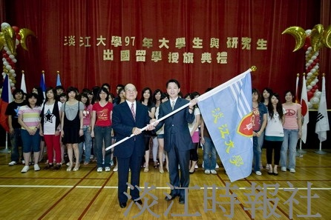
In the 2008 academic year flag-giving ceremony for the Junior Abroad, Graduate Abroad Studying, and Exchange Students Programs, Founder Clement Chang present the flag to chairperson of each department. (Dr. Lin Yi-nan, Chair of Dept. of International Trade, right 1 on the first line).

