Tamkang Times No.713
LEE, A DOCTORAL CANDIDATE, WINS GRANT TO STUDY ECOLOGY IN GERMANY

Lee Shiao-ching, a doctoral candidate from the Department of English, has just been awarded a research grant from National Science Council (NSC) which enables her to spend 18 months in Germany to conduct her research on films that explore ecological issues. She is the only applicant from humanities and a private university that has won this generous grant.

Lee has been interested in issues about nature since she was a college student. She has been to various corners of Taiwan recording ecological processes, and with her keen observations that turned into writing, she has also won several literary awards such as United Daily Reportage Literature Awards, Taipei Literature Awards, and published a number of books on ecology. Since Germany is reputable for its concerns over environmental issues, Lee thinks to study about media, in particular those of films, and their portrait of nature’s interactions with humans and technology in Germany is most appropriate.

This grant is in fact a joint project of NSC and a German academic exchange organization that is known as DAAD that aims to support Ph. D. candidates 6 to 18 months to complete their dissertations. Successful applicants receive flight tickets, living allowance, and expenses for books, insurances, field work, and conferences. In Lee’s case, she is also paid to learn German at the Goethe Institute for two months.

Although Lee’s exposure to German is limited, she is not particularly worried about going to Germany. She started learning German sometime ago, and through Dr. Christa Grewe-Volpp, who was a visiting professor at the English Department last summer, she had learned about Germany and its educational system. “I believe I’m well prepared. Besides, I have a two month cushion time during which the only thing I do is to learn German. I’ll be fine,” she said.

She wants to thank Dr. Huang I-min, the Chair of her department, and Dr. Yang Ming-tu, another professor from the department, who specializes in ecology studies. They inspired and encouraged her to take this step; she is grateful to their help. ( ~Ying-hsueh Hu )
2010/09/27

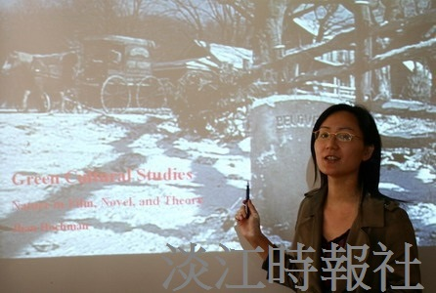
Lee Shiao-ching explains her research project.

