Tamkang Times No.707
MAGPIES, A SYMBOL OF LUCK TO CHINESE, ARE SPOTTED IN CAMPUS

Lately with the warming temperature and extended daylight, the air of spring is definitely around us. Thanks to this inviting weather, several magpies have been spotted in Tamsui Campus, particularly in the Fu Yuan, University Commons and the pedestrian zone in front of the College of Liberal Arts. As magpies, whose Chinese name “His Chieu” literally means “happy/lucky birds,” stand for messengers of good news, TKU sees their presence as a symbol of an auspicious future for the university. ( ~Ying-hsueh Hu )
2010/09/27

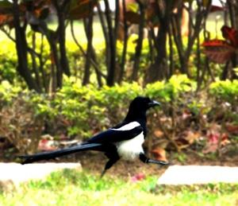
Lately with the warming temperature and extended daylight, the air of spring is definitely around us. Thanks to this inviting weather, several magpies have been spotted in Tamsui Campus, particularly in the Fu Yuan, University Commons and the pedestrian zone in front of the College of Liberal Arts. As magpies, whose Chinese name “His Chieu” literally means “happy/lucky birds,” stand for messengers of good news, TKU sees their presence as a symbol of an auspicious future for the university.

