Tamkang Times No.706
ULTRAVIOLET WATER-PROOF PAINT: CHEN WEI-HUNG WINS FIRST PRIZE IN POSTER PRESENTATION AND APPLIES FOR AMERICAN PATENT

Doctoral student, Chen Wei-hung, recently published a poster essay, “The Application of UV-curable system on Textile Water-repellent Treatment” in 2008 Convention of Polymer Society, Taipei, at NCTU, and won the first prize of poster presentation in “Fiber and Textile Section.” Chen’s paper was directed by Dr. Chen Kan-nan, Vice President for Academic Affairs. In this essay, Chen applies ultraviolet technology to make water-proof cloth soft and ventilating.

Dr. Chen Kan-nan remarks that “The main factor of winning the prize lies in Chen’s originality in applying material consideration in water-proof cloth.” Chen Wei-hung said, “This is part of my dissertation; I used to do research with Professor Chen in Polymer Laboratory. The research is to use UV-induced Technology to replace traditional high temperature environment process. We change from fluorinated chemical solvent to polymer waterproof paint through a chemical reaction, and retaining the original feel and soft of fabric at the same time.”

With his successful experience in acquiring patent on using UV Technology to enhance water absorbency of textiles, Dr. Chen suggests Chen Wei-hung to apply this technology to water-resistance. Present, Chen applies for an American patent on this technology, and cooperates with Institute of Textile Industry and other factory owners. Such a technology is to be applied to raincoat or normal clothes to resist rain water.

Participants in the convention include National Taiwan University, National Tsing Hua University, Fu Jen Catholic University, and Feng Chia University. The technology of “retaining the original feel and soft of fabric” of TKU won favorite attraction. Water-proof cloth usually become harder. This technology can be used to maintain the softness and ventilation of the fabric, and hence won the first prize among forty competitors. This technology can also reduce the dangerous factors in high-temperature working process. It also accords with the concept of “Green Manufacture Process.”

Since 1996 when Chen Wei-hung entered Department of Chemical, he has spent 12 years in TKU. He is expected to graduate soon and leave his beloved campus. He expressed that he will devoted himself to the job related to materials research and development. ( ~Lin Wen-hua )
2010/09/27

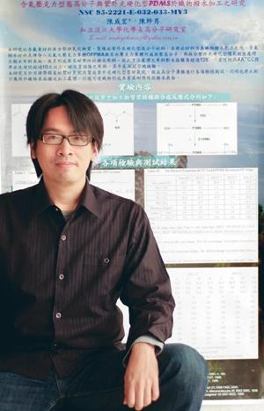
Chen Wei-hung applies Ultraviolet Technology to make water-proof cloth soft and ventilating. His poster essay also wins the first prize in 2008 Convention of Polymer Society, Taipei.

