Tamkang Times No.702
PRESIDENT OF REPUBLIC OF KIRIBATI VISITED TKU: PRAISED HER ACADEMIC PRESTIGE AND FACILITIES

Mr. Anote Tong, President of Republic of Kiribati and Minister of Foreign Affairs, visited TKU and was passionately welcomed by Founder Clement Chang, President C. I. Chang, and many teachers and students. Mr. Tong highly praised the remarkable facilities and architectures of TKU and said, “It is amazing to have such an extraordinary achievement within only 57 years.”

The reception for President Tong was hosted by Dr. Chen Kan-nan, Vice President for Academic Affairs, Mr. Chou Hsin-min, Secretary General of Board of Trustees, and Secratray Chang Chin-hsin. The accompany with President Tong include Mr.Taam Biribo (Permanent Secretary to the Cabinet), Mr.Tom Murdoch (Deputy Secretary of MFAI), Ms. Teea Tira (Permanent Secretary of the Ministry of Finance and Economic Development), Ms.Bwena Mauna (Protocol Officer of MFAI), Ms. Tsai Chia-jung, and Ms. Chen Ting-yen (Receptionists and Secretaries). Mr. Chen Shih-liang was a TKU alumnus, of Dept. of History and Graduate Institute of European Studies. Ms. Tsai Chia-jung, also a TKU alumnus, graduated from Dept. of Spanish, and Graduate Institute of Latin American Studies. Those honorable visitors enjoyed a wonderful memory of TKU. While visiting the main library, Ms. Teea Tira remarked that “the TKU students are hardworking in a liberal university,” and Ms.Bwena Mauna said “it is lucky to be a student in Tamkang.”

Kiribati was independent from British and became Republic of Kiribati in 1979. In 1999, Kiribati joined in United Nation, and in November 2003 established diplomatic relation with R. O. C. Taiwan’s first ambassador to Kiribati, Mr. Chen Shih-liang indicates that “in the whole South Pacific areas, there is only one university--University of the South Pacific, at Fiji—in which President Anote Tong holds a Honorable Presidency; we invite President Tong to visit TKU and establish academic cooperative relations.”

Mr. Anote Tong graduated from the London School of Economics with a master degree. He feels extreme interest in the development of TKU. Among 206 foreign students in TKU, two come from Kiribati. One of the two Kiribatian stuents, Renee Ereri Terawasi, who studies in Dept. of English, also attended the welcoming ceremony. After the warm reception, Mr. Anote Tong and accompanies visited Carrie Chang Music Hall, Maritime Museum, Carrie Chang Fine Arts Center, and Chueh-sheng Memorial Library, then joined banquet in Chueh-sheng International Conference Hall. They felt very impressed by the garden-like, international campus.
2010/09/27

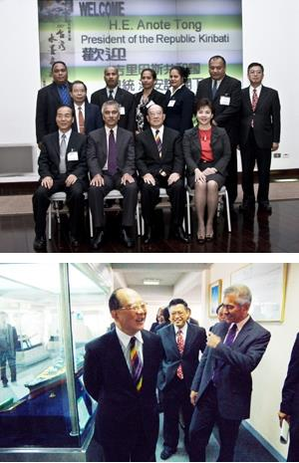
(Front line, from left): Mr. Chen Shih-liang (Taiwan Ambassador to Kiribati), Mr. Anote Tong, President of Republic of Kiribati, Founder Clement Chang, President C. I. Chang.

