Tamkang Times No.678
Wii WAS WON AT STUDY/TRAVEL ABROAD FAIR

Chen Hui-ling, a graduate student from the Chinese Department was the lucky winner who won a Wii at the 2007 Summer Study/Travel Abroad and Global Village Fair. The lucky draw was the highlight of the week-long exhibition, which ended on last Thursday. On that day, the exhibition venue was packed with people, but there could only be one winner for this much sought after game. The fair was organized by the Division of Continuing Education and Student Association of Business and Management. ( ~Ying-hsueh Hu )

Picture: Chen Hui-ling, a grad. student from the Chinese Dept. accepted Wii from Dr. Feng Chao-kang, the Vice President for Academic Affairs.
2010/09/27

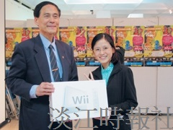
Chen Hui-ling, a grad. student from the Chinese Dept. accepted Wii from Dr. Feng Chao-kang, the Vice President for Academic Affairs.

