Tamkang Times No.637
TKU MEN’S TEAM TOPS THE COLLEGIATE FRIENDSHIP MATCH

The 2006 Northern Collegiate Friendship Match was held on March 11 and 12 at the Student Activity Center of TKU. Tamkang’ s men’s team took the gold, while the ladies’ had to settle for fourth place.

All the matches adopted the new scoring system, which was designed to make the game more thrilling. Apparently, this system enhanced TKU’s performances that its men’s team surpassed strong opponents such as the National Jiao Tong University and the National Taiwan University to reach the final showdown with the Ocean University. TKU won decisively by 93 to 42 to become this year’s champion.

Of course, it is attitude that sets winners from the rest apart. For instance, the team’s deputy captain, Huang Jin-li, a sophomore of the Department of Chemical and Materials Engineering, was hit by the racket, producing a 3cm deep gash. Yet, he continued his double match despite the pain and even won with 21 to all.

The Women’s team did not fare that well in the ladies’ category. TKU’s team lost to the National Cheng-chi University in the quarter final by 4 points only. However, the team captain, Lin Yi-huei, a junior of the Department Mass Communication, is not discouraged by the results as she, together with Liu Jung-ting, the captain of the men’s team, a junior of the Department of Water Resources and Environmental Engineering, see this Friendship Match as the best preparation for the real event, the College Cup later this year.

Furthermore, the coach, Tsai Huei-ming, points out that although TKU is fairly good at doubles, it falls short on singles. Nonetheless, she was pleased with the overall results in this category. “Progress is far more important than anything else!” she says. “Comparing with last year, all players have moved up a notch already. If they can continue to grow and improve, they will shine at the College Cup,” she is convinced.
2010/09/27

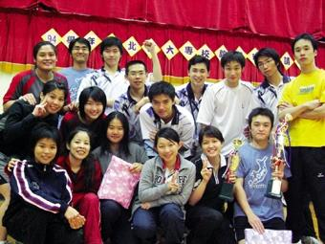
TKU men’s and women’s teams delivered top performance at the 2006 Northern Collegiate Badminton Friendship Match. Men’s won the championship, while women’s settled for fourth. (~ Ying-hsueh Hu )

