Tamkang Times No.636
WHEN THE PRESIDENT MEETS THE PRESIDENT

2010/09/27

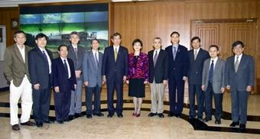
Yuan T. Lee, President of Academia Sinica, meets President Flora C. I. Chang after his speech at Tamkang.

