Tamkang Times No.631
MULTI-LINGUAL E-LEARNING WEBSITE GETS INITIATED

The “Multi-lingual E-Learning Website” [http:// www.multi.tku.edu.tw], a language learning resources web hosted by College of Foreign Languages and Literatures (COFLAL), has been wired to the web since January 1, 2006. From now on, through TKU IP, students may have more channels for learning English, Japanese, German, French, Spanish, and Russian.

Incorporating the characteristics of six departments of the COFLAL and the cultures introduced by the departments, the designer of this website creates six cartoon characters through flash animation and stages them onto the front-page. Professor Su Shwu-yen, from Department of Russian, who participates in the organization of the website, indicates that “I have asked the technicians to simplify the operation process to conform to the need of the computer-slow-hand like me. And I feel the operation process in most language learning software is too complicated to be user-friendly.”

The provided programs on the web consists of two levels (Basic, Advanced), and each level contains five lessons. Each lesson encompasses six units: situational dialogue, short reading, sentence pattern and grammar, cultural background, illustrated vocabulary, and self test. This language-learning program is characterized by “Situational Conversation”, in which the language contexts are situated in all TKU learning spaces, such as Palace-styled Classroom, Chueh-sheng Memorial Library, and MSN and e-mail are incorporated into the modes of communication.

This project is proposed by Dr. Sung Mei-hua, Dean of the COFLAL. The curriculum and learning materials are written and compiled by seven professors and dozen of assistants, including Dr. Kuo Chiu-hsiung (Dept. of English), Dr. Hu Ying-hsueh (Chair, Dept. of Multiculture and Languages, Lanyang Campus), Dr. Wei Jung-chih (Dept. of German), Dr. Hsu Hui-hui (Dept. of French), Dr. Peng Chun-yang (Chair, Dept. of Japanese), Dr. Pei Chau-pu (Dept. of Spanish), Dr. Su Shwu-yen (Dept. of Russian). The software design and digitalization are assisted by some dozen students from departments of Computer Science and Information Engineering, Information Management, Information and Communication, and Educational Technology. The art design is commissioned to graduate students of Tainan National University of the Arts. (~ Chen Chi-szu )
2010/09/27

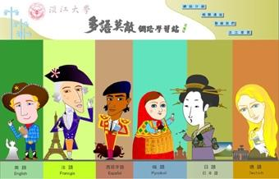
The homepage of the “Multi-language E-Learning Website”, hosted by College of Foreign Languages and Literatures, features with six cartoon characters in ethnic costumes of the six foreign countries.

