Tamkang Times No.625
DALAI LAMA GREETS TKU PROFESSOR WU KUAN AND BLESSES ON THE CENTER OF TIBETAN STUDIES

Professor Wu Kuan, Director of the Center of Tibetan Studies, visited Reverend Dalai Lama, the Tibetan religious leader last month. Prof. Wu informed Reverend Dalai Lama the working of the center and invited him to attend academic conference in Taiwan in the near future. She felt fortunate and blessed to receive Dalai Lama’s autograph for the center and a personal recognition seal.

According to Prof. Wu, though there were only fifteen minutes during the meeting, both she and Dalai Lama were very pleased. Dalai Lama was very happy to know that TKU had established a Tibetan research center and was very surprised that it was done in so short a time, for he met former TKU President Chang Horng-jinh

last year, who informed him about the founding of the center. He blessed on the success of the center in doing academic researches on Tibetan cultures.

Reverend Dalai Lama agreed to attend the cross-strait conference on Tibetalogy, but was not sure whether he can make it. He wished that his attendance would not irritate the Mainland China authority, and he believed that non-political issues in an international context would do him a favor.

Dr. Wu felt very lucky and indicated that “I was the last visitor before His Reverend closed the door for visitors for his deep mediation.” It took a long and tiring trip for her to get to Dharamsala. “I arrived at Delhi, India on 3 am, October 17, and then took a 12 hour night train trip to Dharamsala. The trip was exhausting!” Dalai Lama just returned from Europe and prepared for his deep meditation when Dr. Wu paid the visit. Dr. Wu was the last visitor to be received.

Dr. Wu showed to the Tamkang Times reporter the photograph with Reverend Dalai Lama and her, an autograph attached to the title of the center, and a personal recognition seal, which is unusually for the recognition of Buddhist devotee. (~ Chi-szu Chen )
2010/09/27

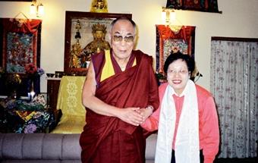
Professor Wu Kuan, Director of the Center of Tibetan Studies visited Reverend Dalai Lama, on October 17. Dalai Lama expressed his bless and gratitude for TKU’s endeavors in studying Tibetan cultures.

